Colwich Parish Youth Council | 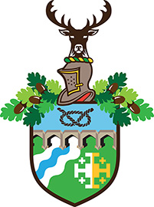  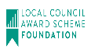

THERE WILL BE A MEETING OF THE YOUTH COUNCIL ON WEDNESDAY 17th JULY 2019 AT THE PARISH CENTRE, ST. MARY’S ROAD, LITTLE HAYWOOD COMMENCING AT 6:30PM.

Michael Lennon  Parish Clerk  12th July 2019 | Youth Council 11 members  Quorum required 3 members

PUBLIC PARTICIPATION (10 MINUTES).

AGENDA

53/19YC TO RECEIVE APOLOGIES.

54/19YC TO RECEIVE DECLARATIONS OF INTEREST.

55/19YC TO CONSIDER REQUESTS FOR DISPENSATIONS UNDER THE 2011 LOCALISM ACT.

56/19YC TO CONSIDER AND AGREE THE MINUTES OF THE MEETING HELD ON 12TH JUNE 2019.

57/19YC TO CONSIDER AND AGREE FINAL ARRANGEMENTS FOR THE MUSIC SHOWCASE ON SATURDAY 27TH JULY 2019.

58/19YC TO CONSIDER AND AGREE STALLS AT THE FLOWER AND VEGETABLE FETE ON SUNDAY 8TH SEPTEMBER 2019.

59/19YC TO CONSIDER THE INVITATION FROM THE TWINNING ASSOCIATION TO ATTEND THE MEETING ON 22ND JULY AND THE VARIOUS EVENTS DURING THE VISIT FROM RIMBACH.

60/19YC DATE OF NEXT MEETING – 11TH SEPTEMBER 2019.

