Colwich Parish Council | 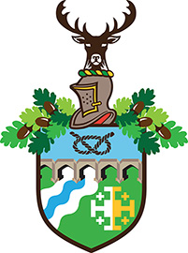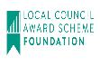
To: Councillors on the Communications Committee

YOU ARE SUMMONED TO A MEETING OF THE COMMUNICATIONS COMMITTEE ON THURSDAY 18TH JULY 2019 AT THE PARISH CENTRE, ST. MARY’S ROAD, LITTLE HAYWOOD, COMMENCING AT 7:30PM.

Michael Lennon  Parish Clerk  12 July 2019 | Committee: 5 members  Quorum: 3 members
PUBLIC PARTICIPATION (10 minutes).

AGENDA.

Item Ref | Agenda item
 | TO RECEIVE APOLOGIES
 | TO RECEIVE DECLARATIONS OF INTEREST
 | TO CONSIDER WRITTEN REQUESTS FOR DISPENSATIONS UNDER THE LOCALISM ACT 2011.
 | TO CONSIDER COMMISSIONING ARTICLES AND INSERTS FOR THE SPRING 2019 NEWSLETTER, TO AGREE DEADLINES FOR RECEIPT OF SAID ARTICLES.
TO REVIEW THE ADEQUACY/EFFECTIVES OF THE EXISTING METHODS OF COMMUNICATION AND, IF CONSIDERED NECESSARY, TO DEVELOP A STRATEGY TO FURTHER ENHANCE THE COMMUNICATION PROCESS/SYSTEMS.
Cllr Dunn to move
TO REVIEW THE ADEQUACY OF THE COMMITTEE’S TERMS OF REFERENCE AND, IF CONSIDERED APPROPRIATE, MAKE RECOMMENDATIONS TO THE SEPTEMBER 19 FULL COUNCIL MEETING.
Cllr Dunn to move
(Please note: the appropriate referral is to the 22nd November Policy Committee meeting.)
 | DATE OF NEXT MEETING: 18TH OCTOBER 2019

Newsletter Committee Membership 2019/20: Cllr Bloor (Chair); Cllr Wells (Vice Chairman); Cllr Billingsley; Cllr Dunn and Cllr Rattray.

