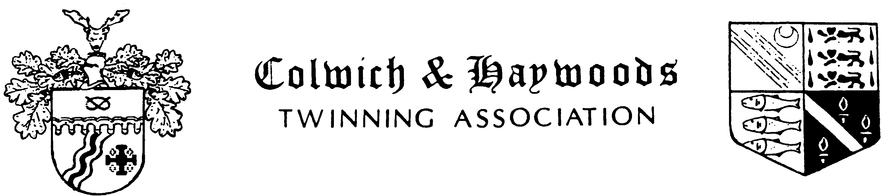

Minutes of Committee Meeting held on Monday 19th February 2018
at the Great Haywood Sports & Social Club

Present: Annette Bloor, Alan Bloor, Liz Bateman, Adele Bateman, Chris Rivers,
Lloyd Dulson, Victoria Jenkinson, Amyas Stafford Northcote,
Denis Cheney, Christine Hill, Keith Butler, Jill Powell

Apologies: Andy Cooper, Chris Jenkinson

Minutes
The minutes of the meeting held on 9th January 2018 were agreed as a true record.

Matters arising
None

Treasurer’s Report
Treasurer Lloyd advised that he had received £285 so far in respect of the Twinning Dinner at the Clifford Arms on 6th March. Otherwise there was no change to the figures presented at the previous meeting.

2018 visit to Rimbach
Annett Bloor presented an update on the status of the proposed visit to Rimbach – copy attached. An official invitation has been received from Rimbach for our visit to take place in July 2018. For various reasons this is not a viable option for our Association members, and it was agreed that we would contact Norman Leigh to advise him that we would prefer the visit to take place in October. Should this be acceptable, it is believed that we would be able to raise the 35 passengers required to obtain the quoted price for coach travel. If the Youth Group also decide to travel with us in October, it may be possible to obtain a reduction on the price currently being quoted.

It is proposed that the visit should take place between Saturday 27th October and Saturday 3rd November, with travel by coach and ferry, and an overnight stop on both the outward and return journeys. Christine will contact Happy Days to obtain a revised quotation based on staying in a hotel in Belgium (Leuven) on the outward journey, and in France (near Le Touquet) on the return journey.

Amyas Stafford Northcote was asked to enquire of Colwich Paris Council about possible financial support towards the travel costs for members of the Youth group.

Social/Fundraising events
We are fully booked for the evening meal being held at the Clifford Arms, Great Haywood, on Tuesday 6th March. Over 40 members will be attending.

Keith Butler advised that arrangements had been made for a Skittles Evening with Fish & Chip Supper to be held on Saturday 28th April at Colwich & Little Haywood Village Hallat a cost of £15 per person. Details of the event to be sent to all Association members.

Any other business
Annette has prepared an article about the Twinning Association, to be included in the next issue of the Parish Newsletter.

Next Meeting
The next meeting committee will be held on Monday 16th April 2018, 7.30 pm at the Great Haywood Sports & Social Club.

The Annual General Meeting will take place on Monday 21st May, 7.30 pm at the Great Haywood Sports & Social Club.

.

